Predicting NBA Player Turnovers Using Age and Experience-Based Factors

Elyse Pender & Helena Callil Tomei
Department of Statistics, Grinnell College
STA 310: Statistical Modeling
Professor Shonda Kuiper

Abstract

Turnovers represent a critical loss of offensive opportunity in basketball, yet they’re often evaluated without considering how player experience shapes ball security. This analysis examines which player characteristics best predict the average number of turnovers per game in the NBA using five seasons of data (2020-2025). After restricting the sample to players averaging at least twenty-five minutes per game, the dataset included 657 player-season observations. Best subsets regression identified field goal attempts, free throw attempts, defensive rebounds, assists, and personal fouls as the strongest predictors of log-transformed turnovers, explaining 82.3 percent of the variation. Adding age provided strong evidence of improved model fit according to an extra sum of squares test, although the increase in explanatory power was small (R-squared increased by 0.007). The negative coefficient for age supports the hypothesis that older players commit fewer turnovers. These findings demonstrate that offensive workload is the primary driver of turnovers, with experience contributing a small effect.

Introduction

Turnovers are a central component of basketball performance because each lost possession eliminates an opportunity to score and can immediately create offensive advantages for the opposing team. Prior research has shown that turnovers influence offensive efficiency and often differentiate winning and losing teams. Karamousalidis et al. (2025) found that winning NCAA teams consistently committed fewer turnovers than losing teams, particularly in passing and ball-handling situations, even though turnover frequency alone did not reliably predict game outcomes. At a professional level, turnovers, shooting efficiency, and rebounds have been identified as major predictors of point margin and overall team success (Jones & Magel, 2016). In addition, research shows that while younger NBA players may have higher athleticism and potential, older players tend to have higher tactical understanding and technical skills and would thus commit fewer turnovers (Xiao et al., 2025).
Although prior studies have examined turnovers across teams, offensive phases, and player positions, relatively little work has focused on how age and experience explain individual turnover behavior over multiple seasons. Understanding how offensive responsibility, play-making involvement, and experience contribute to ball security can provide deeper insight into the mechanisms behind turnovers. This analysis addresses this gap by examining five seasons of NBA player data to determine which variables best predict a player’s average turnovers per game. Our primary hypothesis is that age will be negatively associated with turnovers, meaning older players will commit fewer turnovers after accounting for offensive workload.

Methods

Data Collection

Data was obtained from Basketball Reference, which is a subcomponent of the highly reputable Sports Reference company. Five NBA seasons were compiled (2020-2021 through 2024-2025). To ensure comparability among players, we restricted the sample to players averaging at least twenty-five minutes per game. This selection removed players with limited playing time or injury-related absences, and resulted in the final dataset including (n = 657) player-season observations. Team winning percentage for each season was collected from StatMuse to examine whether team strength might be associated with turnover behavior.

Variable Creation

The response variable was turnovers per game (TOV), and the key offensive predictors included field goal attempts (FGA), free throw attempts (FTA), assists (AST), and defensive rebounds (DRB). These explanatory variables each reflect a player's association with ball involvement. Personal fouls (PF) were included as a potential indicator of defensive pressure, and age, which was measured in years, was included to capture a player's experience. Additionally, transformations were applied to explanatory variables where residual diagnostics indicated nonlinearity or heteroscedasticity. We also added season as an indicator variable to assess whether year-to-year differences affected the average number of turnovers. Lastly, position was made as an indicator variable to determine whether the position a player played impacted how many turnovers they would have, since different positions have different responsibilities, particularly regarding ball handling and shooting.

Analytic Methods

Best subsets regression was used to identify a parsimonious reduced model with strong explanatory power. Since an initial best subsets analysis including all predictors generated a large twenty-variable model, a second best subsets run was conducted using the ten most meaningful predictors to simplify the model with minimal loss in R-squared. A linear regression model was then fitted using log(TOV) since there wasn't constant variance as can be seen in the residuals vs. fits plot (Figure 1 of the Appendix). Residual plots were examined to assess normality, linearity, and constant variance. To test whether age contributed additional explanatory value, a full model including age was fitted and compared to the reduced model using an extra sum of squares test.

Results

The final dataset included (n = 657) player-season observations. Age ranged from 19 to 40 years old (M = 26.4, SD = 4.25). Best subsets regression identified five variables as the optimal reduced model predictors: FGA, FTA, DRB, AST, and PF. The reduced model had an R-squared of 0.811. After examining residual diagnostics, transformations were applied to TOV, FGA, FTA, DRB, and AST to account for the heteroscedasticity. This model explained 82.28 percent of the variation in log-transformed turnovers and showed no violations of linear model assumptions, which can be seen in Figure 3 of the Appendix. A full model was then fitted by adding age. As seen in Table 1 of the Appendix, Age had a negative coefficient (β = −0.009), indicating that older players tended to commit fewer turnovers, consistent with the hypothesis. The full model achieved an R-squared of 0.83, increasing explanatory power by 0.007 relative to the reduced model. An extra sum of squares test provided strong evidence that adding age improved model fit (F = 27.85, p < .001), although the practical effect of age was small.

Discussion

This study aimed to determine whether age predicts NBA turnovers after accounting for offensive workload. The reduced model demonstrated that turnover behavior is strongly tied to usage-based variables: players who shoot more, initiate offense, or handle the ball more frequently commit more turnovers. These variables alone explained 82.3 percent of the variation in log-transformed turnovers. Consistent with our hypothesis, adding age improved model fit and produced a negative coefficient, indicating that older players commit slightly fewer turnovers. The ESS test provided strong evidence of improvement, but the practical effect was small: R-squared increased by only 0.007, suggesting that experience influences turnovers modestly compared to offensive volume. This aligns with literature showing that turnovers stem primarily from actions requiring decision-making under pressure (Hudl, 2023; AVCSS, 2024), while experience refines decision-making but cannot fully offset the risks associated with high-usage roles. These findings integrate with prior research showing that turnovers contribute to game outcomes and reflect tactical behaviors (Karamousalidis et al., 2025; Jones & Magel, 2016). While older players may possess greater discipline and situational awareness, the dominant factor in turnover behavior remains workload, not age.
Several limitations warrant consideration. Restricting the sample to players averaging at least 25 minutes per game excludes bench players and younger developmental players who may behave differently. Turnovers per game also do not account for possession volume, as turnover percentage may offer a more refined measure. Additionally, nonlinear effects or position-specific dynamics may result in a more in-depth analysis. Overall, the findings provide a clearer statistical understanding of turnover behavior in the NBA: experience offers a small stabilizing effect, but turnover patterns are driven overwhelmingly by offensive responsibility and usage. Future analyses incorporating possession-based metrics and advanced tracking data could further refine these insights.

Appendix

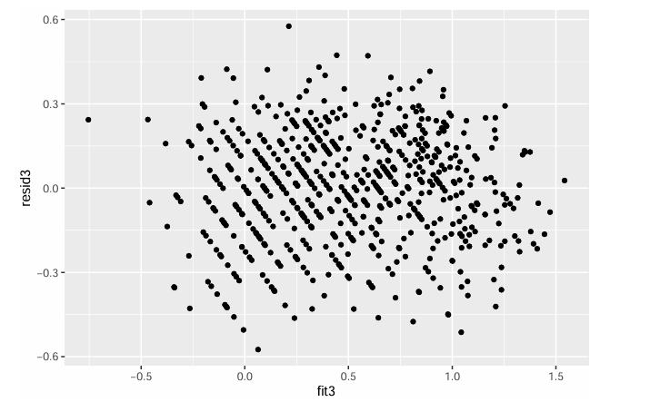
Figure 1. Residuals vs Fits Plot

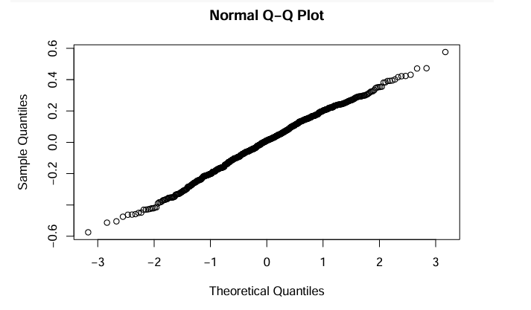
Figure 2. Normal qqplot
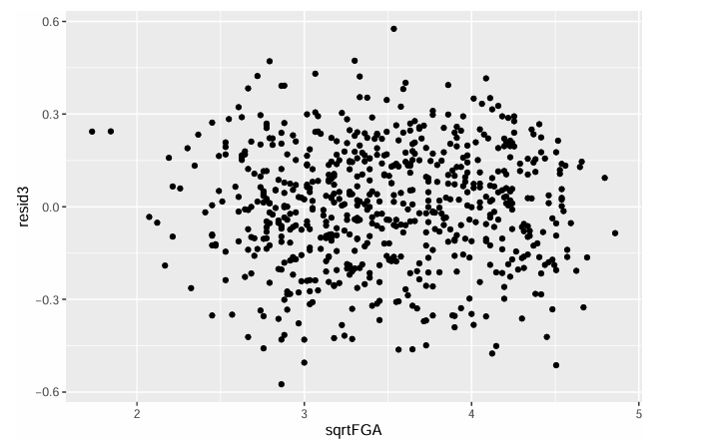
Figure 3. Residuals vs Sqrt(FGA)

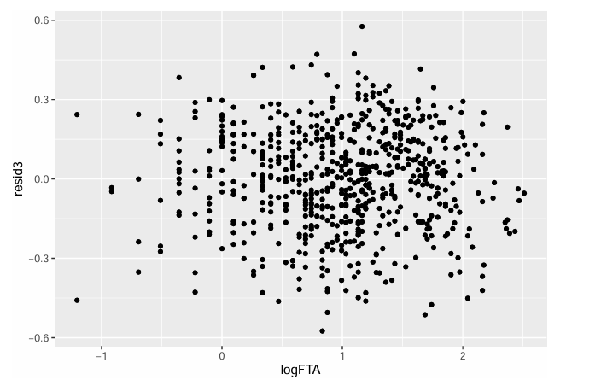
Figure 4. Residuals vs Log(FGA)

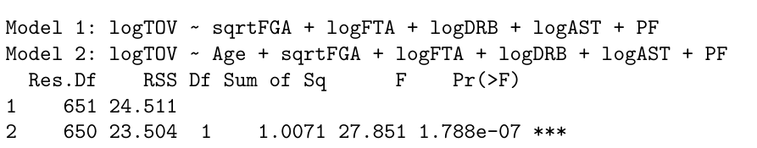
Figure 5. ANOVA table for the Extra Sum of Squares Test

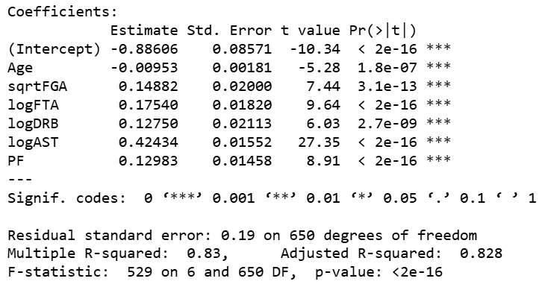
Figure 6. Table of Coefficients for the full model with Age added

References

AVCSS Basketball. (2024). Turnover in Basketball: Definition and Impact.
https://avcssbasketball.com/turnover-in-basketball/

HoopTactics. (2024). Basketball Statistics and Analytics.
https://hooptactics.net/premium/basketballbasics/bb10statisticsanalytics.php

Hudl. (2023). Turnover Percentage: The Trustworthy Measurement for Ball Security.
https://www.hudl.com/blog/turnover-percentage-the-trustworthy-measurement-for-ball-security

Jones, E. S., & Magel, R. C. . (2016). PREDICTING OUTCOMES OF NBA BASKETBALL
GAMES. Journal of Advance Research in Business, Management and Accounting (ISSN: 2456-3544), 2(5), 15-24. https://doi.org/10.53555/nnbma.v2i5.99

Karamousalidis, G., Foteinakis, P., & Kourtis-Doulkeridis, A. (2025). Turnover Dynamics in
NCAA Division I Men’s Basketball: A Structural Analysis by Game Outcome, Player Position, and Offensive Phase. Sport Mont, 23(3), 3-11. doi: 10.26773/smj.251001

Mikołajec, K., Maszczyk, A., & Zając, T. (2013). Game Indicators Determining Sports
Performance in the NBA. Journal of human kinetics, 37, 145–151. https://doi.org/10.2478/hukin-2013-0035

NBA & ABA League index. Basketball. (n.d.). https://www.basketball-reference.com/leagues/

NBA stats. StatMuse. (n.d.). https://www.statmuse.com/nba

Sports Journeys International. (2023). Turnover Percentage: The Second Most Important Factor
of Basketball Success. https://sportsjourneysinternational.com/sji-coaches-corner/turnover-percentage-the-second-most-important-factor-of-basketball-success/

Xiao, Y., Wang, J., Li, W., Chen, J., Chang, N., Song, Y., & Xu, Z. (2025). Nonlinear Age Effects
on Basketball Player Performance: Insights from Kolmogorov–Arnold Networks in NBA Data. Frontiers in Sports and Active Living, 7, 1693433. https://www.frontiersin.org/journals/sports-and-active-living/articles/10.3389/fspor.2025.1693433/full?utm_source=chatgpt.com

You Reach I Teach. (2024). How to Avoid Basketball Turnovers.
https://youreachiteach.com/how-to-avoid-basketball-turnovers/

